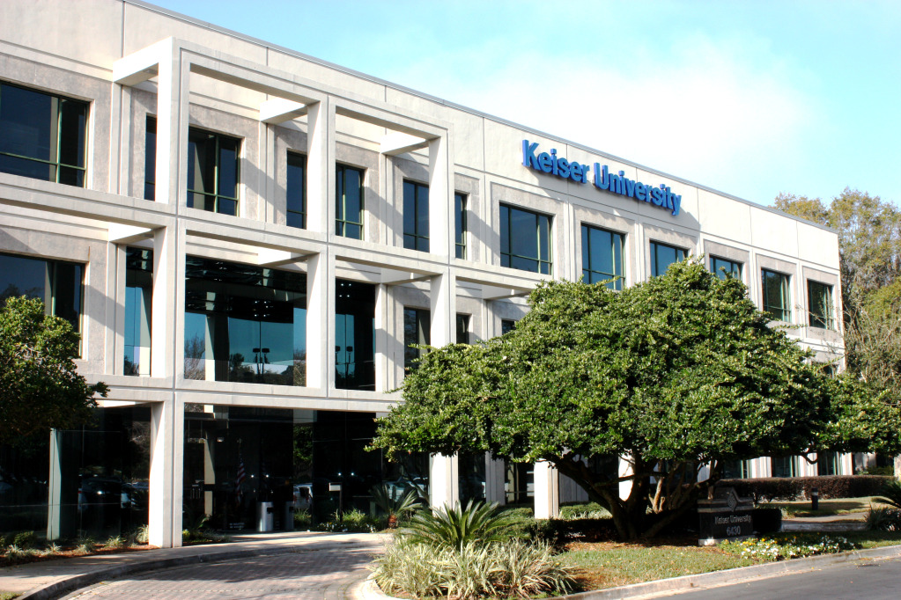
KEISER UNIVERSITY
JACKSONVILLE COMMUNITY OUTREACH
FREE
SAT/ACT
TEST PREP CLASSES
SATURDAYS: 10:00 a.m.- 12:00 noon
KEISER UNIVERSITY
6430 SOUTHPOINT PARKWAY, JACKSONVILLE
CALL: (904) 296-3440 to sign up

