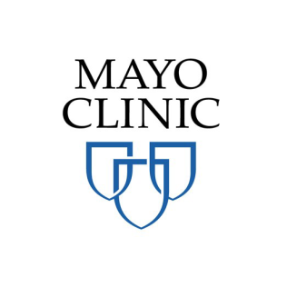
Take the opportunity to explore potential career avenues in health care! Join us for:
High School Health Care Boot Camp !
Hosted by Mayo School of Health Sciences
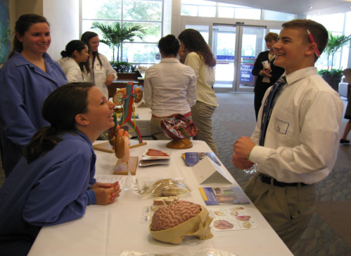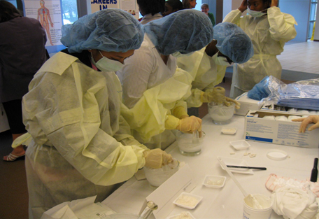
Date – Saturday, April 11, 2015
Time – 8:30 a.m. – 2:30 p.m.
Location – J. Wayne and Delores Barr Weaver Multidisciplinary Simulation Center
- An excellent experience – Free of Expense
- Space is limited – “First-come , first – served”
- Lunch is complimentary to all students
- Apply! Contact: padilla.ana@mayo.edu

